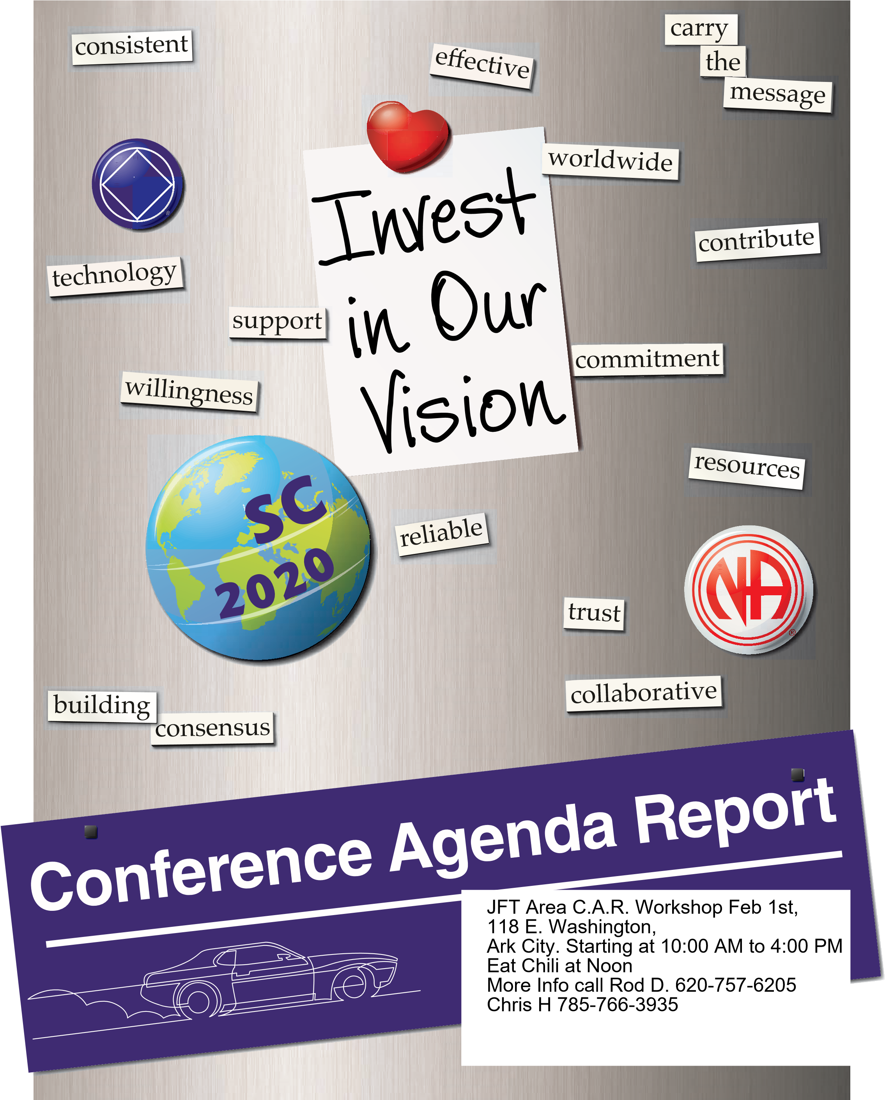

Wichita Metro CAR Workshop Feb 29th 1:00 PM Living Clean Group 3735 West Douglas, Wichita More Info Call Rod D 620-757-6205 Chris H 785-766-3935

Fellowship for Freedom Area C.A.R. Workshop Feb 23rd, 27th and Western, Topeka, KS. 1:00 PM to 3:00 PM More Info call Rod D 620-757-6205 or Chris H 785-766-3935